* It requires no prior knowledge of any querying language like SQL, Excel. Querying is carried out using the common and natural English language.
* Once the dashboard is created and submitted to Business stakeholders, stakeholders find it easy to query on their own in the report submitted by the Analyst Team.
* Power BI shows predictions as the user types the query which indeed helps the user to query faster and confidently.
* It reduces confusion to a layman

for example, we may query **"show total sales country wise"**. Power BI understands the query as we type. When we type "show" it lists all the features available. The respected query results are displayed to user/Business stakeholders.

## 2. The front-end cluster acts as an intermediary between the client and the back end.

## It uses **Azure Traffic Manager (ATM)** to make efficient and quick authentication. It attempts to send user traffic to the nearest data center to reduce connection time. The nearest location is found by the DNS record of the client attempting to connect.

## Once the user is connected, he/she can access static content & files. To share these files, Power BI uses another technology called **Azure Content Delivery(ACD)** to efficiently distribute the respective user file contents based on geographic locale.

## Power BI uses **Azure Active Directory (AAD)** to authenticate users who sign in to the Power BI service, and in turn, uses the Power BI login credentials whenever a user attempts to access resources that require authentication

3. The Power BI services at the back end take care of

* visualizations
* datasets
* storage
* reports
* data connections
* data refreshing and other interactions with Power BI.

At the back end, a web client has only two direct points of interaction

* Azure API Management
* Gateway Role.

4. The ASP.NET component plays a major role in publishing reports and dashboards to the workspace where stakeholders interact with it in the front end provided by the Power BI service. Not only that, BI dashboards can also be accessed through other apps like Microsoft Teams which embeds BI applications through ASP.NET framework.

5.

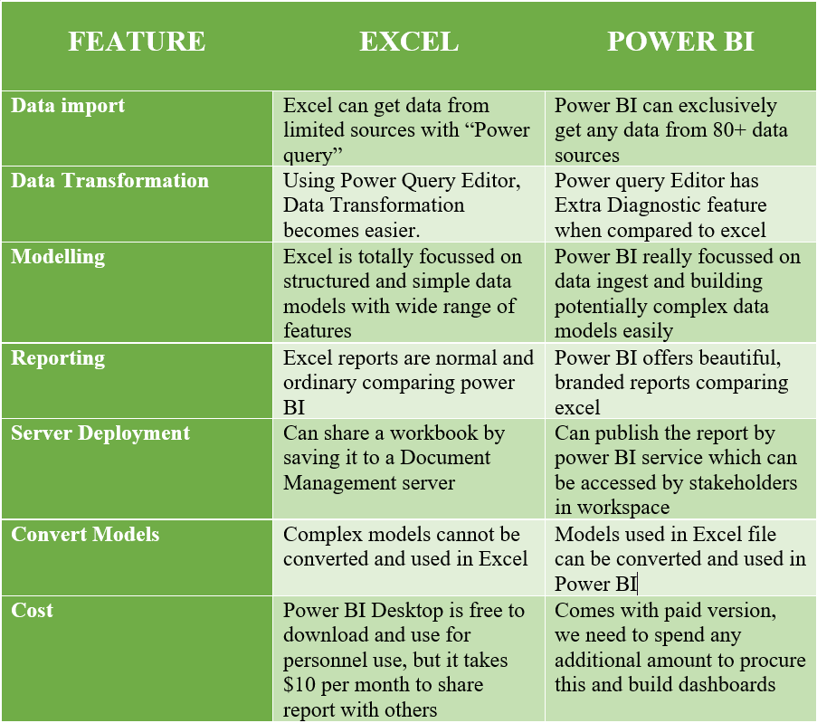

### **6.** 20 data sources supported by Power BI desktop.

* Access database
* Oracle Database
* IBM Netezza
* Mysql Database
* Postgre Database
* Teradata Database
* Amazon Redshift
* Impala
* Google Bin query
* Vertica
* Snowflake
* Essbake
* Azure SQL Database
* Sharepoint Online list
* Microsoft Exchange online
* Dynamics 365(online)
* Adobe Analytics
* Github(beta)
* Linkedin Sales Navigator(Beta)
* Twilio(beta)